Name : Muhammad Redzuan Bin Parsikun
Matrix.No : 03DDT21F1005
1) Coding
"""
Food Order - exception.py
"""

import os

import datetime

import re

food_price = 0.00
beverage_price = 0.00
total_price = 0.00
delivery_charge = 4.00
payment = 0.00
total_overall = 0.00
inputNumberIC = False
inputNumberPhone = False
inputNumberPostCode = False
inputEmailAddress = False

print("++--------------------------------------++")
print("+ WELCOME +")
print("++--------------------------------------++")

now = datetime.datetime.now()
print("Current date : ",now.strftime("%Y-%m-%d"))
print("Current time:",now.strftime("%H:%M:%S"))
print("Today is : ",now.strftime("%A"))
print()

orderTime = str("******Order Time******")
inputDate = now.strftime("%Y-%m-%d")
inputTime= now.strftime("%H:%M:%S")
inputDay = now.strftime("%A")

print("-------------------------------------------")
print("*** Please Insert Your Info ***")
print("-------------------------------------------")
line1= str ("\n*****CUSTOMER DETAIL*****")

inputName = str(input("Name : "))
while not input:
print("Your name is empty. Please insert your name again")
inputName = str(input("Name : "))
continue
while True:
break

while not inputNumberIC:
inputIC = str(input("IC :"))
if len(inputIC) == 12:
inputNumberIC = True
elif len(inputIC) == 0:
print("Your IC is empty. Please insert your IC again")
inputNumberIC = False
else:
print("Invalid IC Number")
break

print()
print("Please fill up your adrress")

inputStreet = str(input("Street : "))
while not inputStreet :
print("Your steer is empty. Please insert your street again")
inputStreet = str(input("Street : "))
while True:
break

while not inputNumberPostCode:
inputPostCode = str(input("Postcode : "))
if len(inputPostCode) == 5:
inputNumberPostCode = True
elif len(inputPostCode) == 0:
print("Your Postcode is empty. Please insert your city again")
inputNumberPostCode = False
else :
print("Invalid Postcode Number")
break

inputCity = str(input("City : "))
while not inputCity:
print("Your city is empty. Please insert yout city again")
inputCity = str(input("City : "))
continue
while True:
break

inputState= str(input("State : "))
while not inputState:
print("Your state is empty. Please insert your state again")
inputState = str(input("State : "))
continue
while True:
break

inputAddress = (inputStreet + "," + inputPostCode + ","+inputCity + ","+ inputState)

print()
while not inputNumberPhone:
inputPhone = str(input("Phone num: "))
if len (inputPhone) == 10:
inputNumberPhone = True
elif len (inputPhone) == 11:
inputNumberPhone = True
elif len (inputPhone) == 0:
print("Your phone number is empty. Please insert your phone number again")
inputNumberPhone = False

else:
print("Invalid phone number")
break

while(True):
inputEmail = str(input("Email : "))
if re.match(r"[^@]+@[^@]+\.[^@]+",inputEmail):
break
elif len(inputEmail) == 0:
print("Your email is empty. Please insert your email again")
inputEmailAddress = False
else:
print("Email is not valid")
continue

def input_info():

with open('Order.txt','w+') as out:
out.write('{}\n{}\n{}\n{}\n{}\n{}\n{}\n{}\n{}\n{}\n'
. format(orderTime, "Date : "+inputDate,"Time : "+inputTime,"Day : "+inputDay,
line1,"Name : "+inputName,"IC : "+inputIC, "Address : "+inputAddress,
"PhonNum : "+inputPhone, "Email : "+inputEmail))

input_info()

print()
print("Please select your food and beverage")
print()

data1 = str("++----------------FOOD MENU------------------++")
data2 = str("+ CODE MENU PRICE +")
data3 = str("+ 1. Burger Set (RM 11.00) +")
data4 = str("+ 2. Pizza Set (RM 11.00) +")
data5 = str("+ 3. Spaghetti Bolognese Set (RM 12.00) +")
data6 = str("+ 4. Spaghetti Aglio Set (RM 13.00) +")
data7 = str(" ")
data8 = str("++----------------BEVERAGE MENU------------------++")
data9 = str("+ CODE MENU PRICE +")
data10 = str("+ 1. Coca Cola * +")
data11 = str("+ 2. Pepsi * +")
data12 = str("+ 3. Fanta Strawberry * +")
data13 = str("+ 4. Fanta Orange * +")
data14 = str("+ *Included in the Food Set +")
data15 = str("++-----------------------------------++")

def show_item():

with open('Menu.txt','w+') as out:
out.write('{}\n{}\n{}\n{}\n{}\n{}\n{}\n{}\n{}\n{}\n{}\n{}\n{}\n{}\n{}\n'
. format(data1,data2,data3,data4,data5,data6,data7,
data8,data9,data10,data11,data12,data13,data14,
data15))

file = open('Menu.txt','r')
print(file.read())

show_item()

print("Please choose your favourite food and beverage")

def food_input_menu(a):
pass

while True:

food = int(input("Food code: "))
if food == 1:
food = "Burger Set"
food_price = 11.00
food_code =1
break
elif food == 2:
food = "Burger Set"
food_price = 11.00
food_code = 2
break
elif food == 3:
food = "Spaghetti Bolognese Set"
food_price = 12.00
food_code = 3
break
elif food == 4:
food = "Spaghetti Aglio Set"
food_price = 13.00
food_code = 4
break

print()

def beverage_input_menu(a):
pass

while True:

beverage = int(input("Food code: "))
if beverage == 1:
beverage = "Coca Cola"
beverage_price = 0.00
break
if beverage == 2:
beverage = "Pepsi"
beverage_price = 0.00
break
if beverage == 3:
beverage = "Fanta Strawberry"
beverage_price = 0.00
break
if beverage == 4:
beverage = "Fanta Orange"
beverage_price = 0.00
break

print("Invalid input. Please try again")
print()
print("Food code: ", food_code)

total_price = food_price + beverage_price
total_overall= total_price + delivery_charge

print("--------------------------------------")
print("Dear ", inputName, ",")
print("Your order is ", food, "RM", food_price)
print("Your order is",beverage,"RM",beverage_price)

print("--------------------------------------")
print()

print("Food price =RM" , format(food_price,'.2f'))
print("Beverage price =RM" , format(beverage_price,'.2f'))
print("Total price =RM" , format(total_price,'.2f'))
print("Delivery price =RM" , format(delivery_charge,'.2f'))
print("___________________________________________________")
print("Total =RM",format(total_overall))

def payment_balance(a):
pass

while True:

payment = int(input("Cash payment = RM "))
if payment > total_price:
balance = payment - total_overall
print("Balance = RM ",format(balance,'.2f'))
break
elif payment < total_price:
print("Your amount is not enough")
print()
continue

print()

print()
print("Your order will arrive with in 30 minutes")
print()

foodPrice= str(food_price)
beveragePrice = str(beverage_price)
totalPrice = str (total_price)
deliveryCharge = str(delivery_charge)
totalOverall = str(total_overall)
Payment = str(payment)
Balance = str(balance)

append = open("Order.txt","a")

append.write("\n*****ORDER INFORMATION*****")
append.write("\nFood : " +food + "(RM" + foodPrice +")")
append.write("\Beverage : " +beverage + "(RM" + beveragePrice +")")
append.write("\n")
append.write("\n*****PAYMENT INFORMATION*****")
append.write("\nTotal Price : RM"+ totalPrice)
append.write("\nDelivery Charge : RM"+ deliveryCharge)
append.write("\nTotal : RM"+ totalOverall)
append.write("\nPayment : RM"+ Payment)
append.write("\nBalance : RM"+ Balance)

append.close()

def yes_or_no():
print("Do you want to view your receipt order?")
print("[y]=Yes / [n]=No")
YesNo = input("View Receipt? : ")
print()

YesNo = YesNo.lower()

if(YesNo == "y"):
return 1
elif(YesNo == "n"):
return 0
else:
print("Invalid Input")
return -1

while(True):
inp = yes_or_no()
if(inp == -1):
continue
elif(inp == 1):
file = open('Order.txt','r')
print(file.read())
elif(inp == 0):
print("++-----------------------------------++")
print("+ THANK YOU +")
print("++-----------------------------------++")
break
break

2) Output
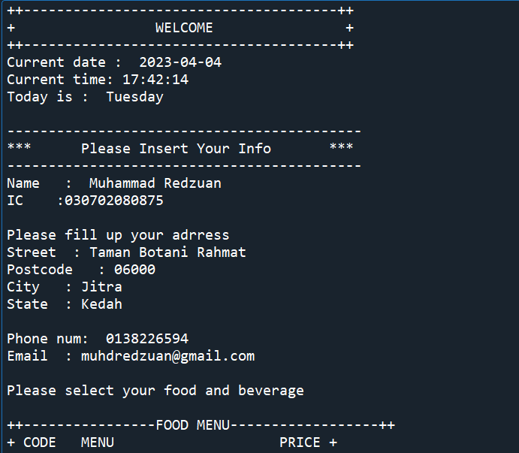
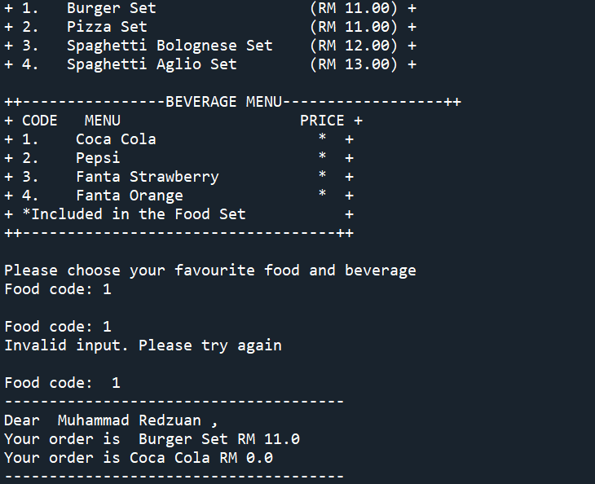
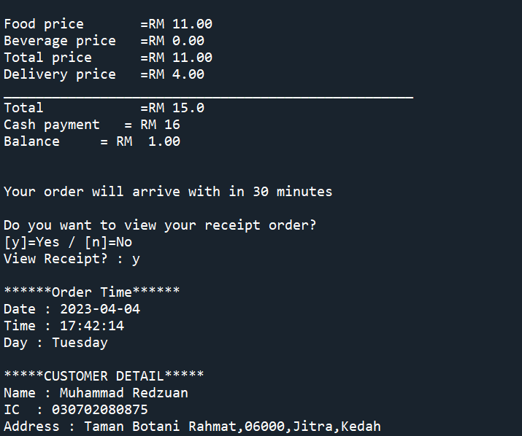
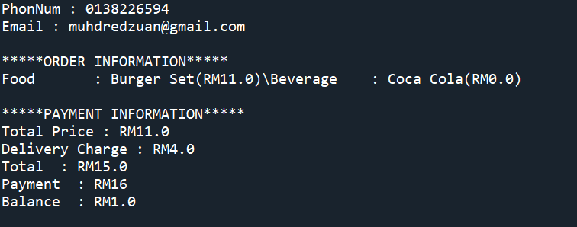

Menu.txt
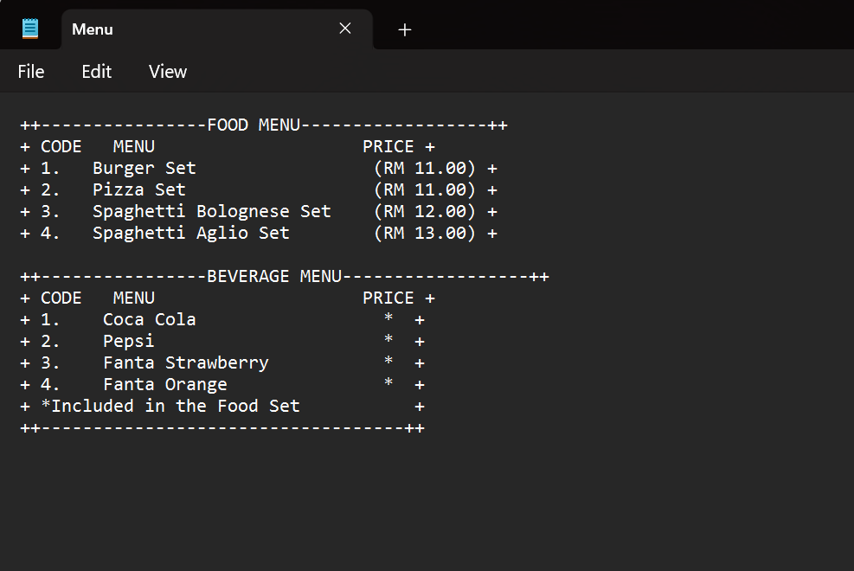

Order.txt